**Web Page Authentication**

In this we'll create a simple registration and login system using the PHP and MySQL. This tutorial is comprised of two parts: in the first part we'll create a user registration form, and in the second part we'll create a login form, as well as a welcome page. this section we'll build a registration system that allows users to create a new account by filling out a web form. But, first we need to create a table that will hold all the user data.

1. Create a registration form page –

We've used the Bootstrap framework to make the form layouts quickly and beautifully. I have developed the responsive signup page by using bootstrap which is a free, open-source front-end development framework for the creation of websites and web apps. It contains HTML, CSS and JavaScript-based design templates for forms, buttons, navigation, and other interface components.

In this form, I have taken several input fields to take the user’s information.

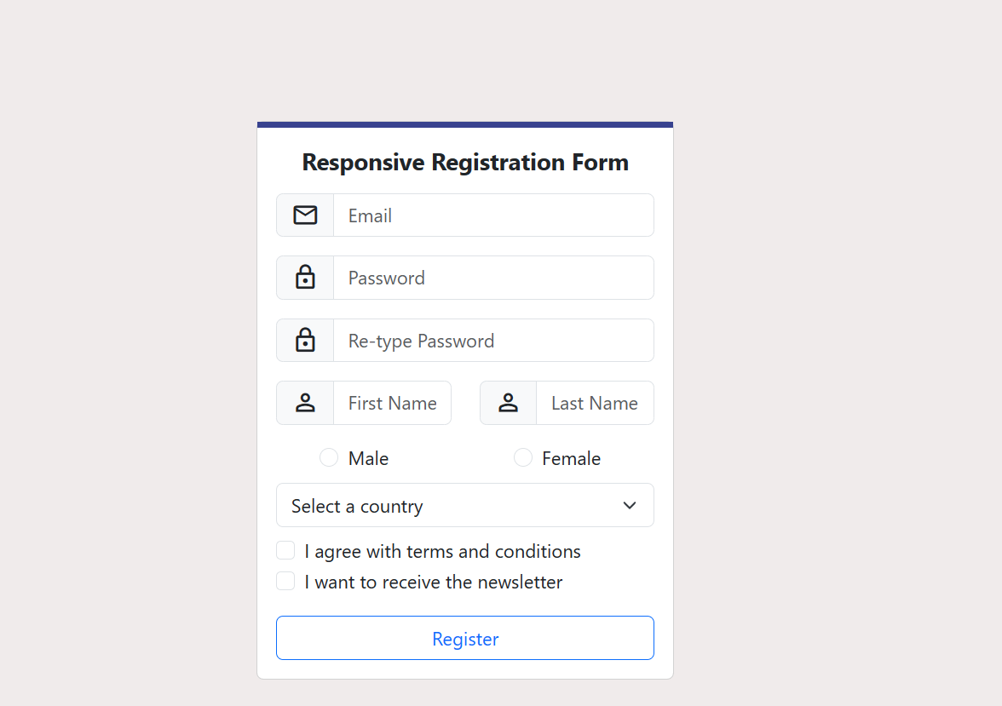

1. Connect to Database and save signing up users -

To perform database connectivity, I have created a PHP script in order to connect to the MySQL database server. I have create a file named "db.php" and in this file which all the info related to it is provided such as servername, username, password ,database name etc. In the database connectivity need to access using [phpMyAdmin](https://www.phpmyadmin.net/) database management application.

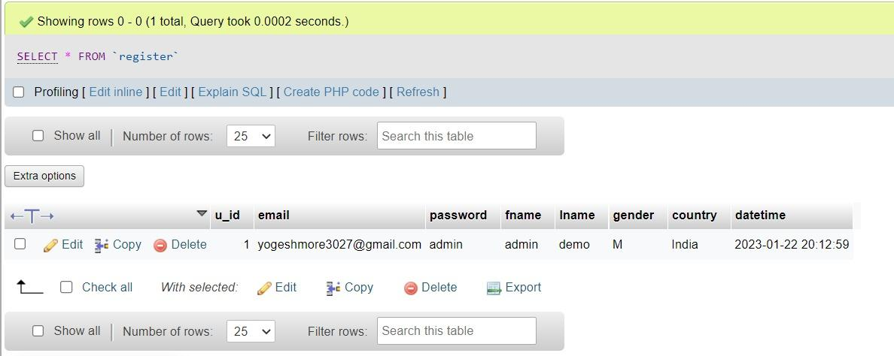

The SQL statement code will create the register table with the columns id, email, password, fname, lname, gender, country, datetime. The SQL statement will insert a test account with the username: yogeshmore3027@gmail.com, and the password: admin. The test account will be used for testing purposes to ensure our login system is functioning correctly. If the user tries to access the file without submitting the form, it will output a simple error.

1. Login page -

In this section I have create a login form where user can enter their username and password. We need to name our form fields so the server can recognize them. The value of the attribute name we can declare as username, which we can use to retrieve the post variable in our authentication file to get the data, for example: $_POST['email'].

It contains HTML, CSS and JavaScript-based design templates for forms, buttons, navigation, and other interface components.I use Javascript alert for display message.The alert(‘hello’) method is used when you want information to come through to the user.

We need to use both the action and post attributes. The action attribute will be set to the authentication file. When the form is submitted, the form data will be sent to the authentication file for processing. In addition, the method is declared as post as this will enable us to process the form data using the POST request method.

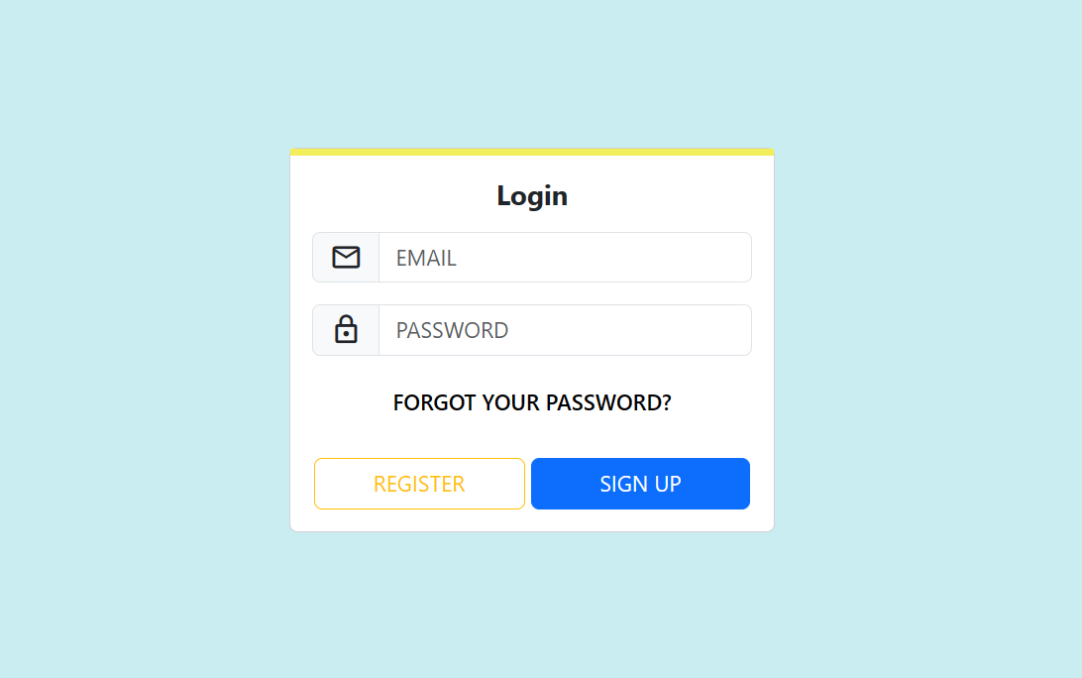

After Successful login display message ‘Login Successful’.

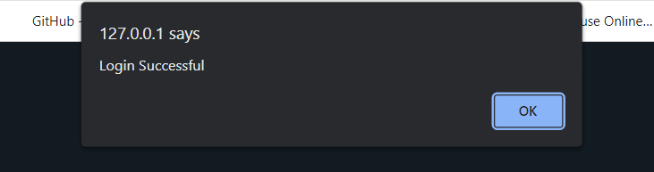



1. Github url –

<https://github.com/yogeshmore3027/Web-Page-Authentication_Task_01>